Name: janani.k
Reg No: 192511243
EXP NO 6:
DATE: 08/08/2026
CREATE A SIMPLE CLOUD SOFTWARE APPLICATION FOR PRODUCT SELLING USING ANY CLOUD SERVICE PROVIDER TO DEMONSTRATE SAAS.
AIM:
To create a simple cloud software application for product selling using any cloud service provider to demonstrate saas.
PROCEDURE:
step1: Go to zoho.com.
step 2: Log into the zoho.com.
step 3: Select one application step.
step4: Enter application name as product selling.
step 5: Created new application as product selling.
step 6: Select one form
step 7: The software has been created.

Implementation

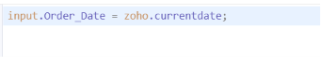
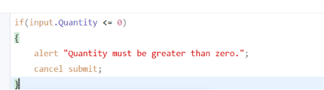
Output
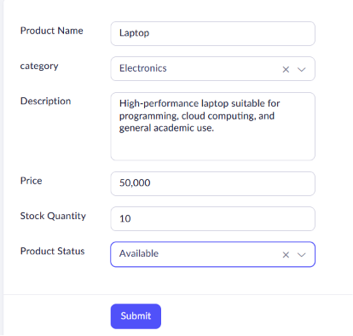
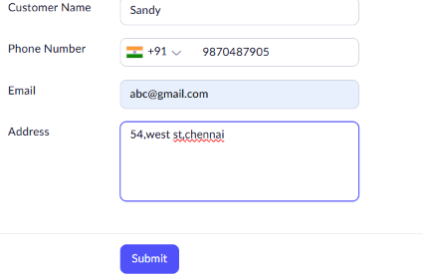
Result
The Product Selling System was successfully developed using Zoho Creator. The application allows users to manage product details, customer information, and product orders through a cloud-based platform. The system successfully demonstrates the Software as a Service (SaaS) model.

